*ROBBINS FARMERS DAY*

*5K RUN/WALK*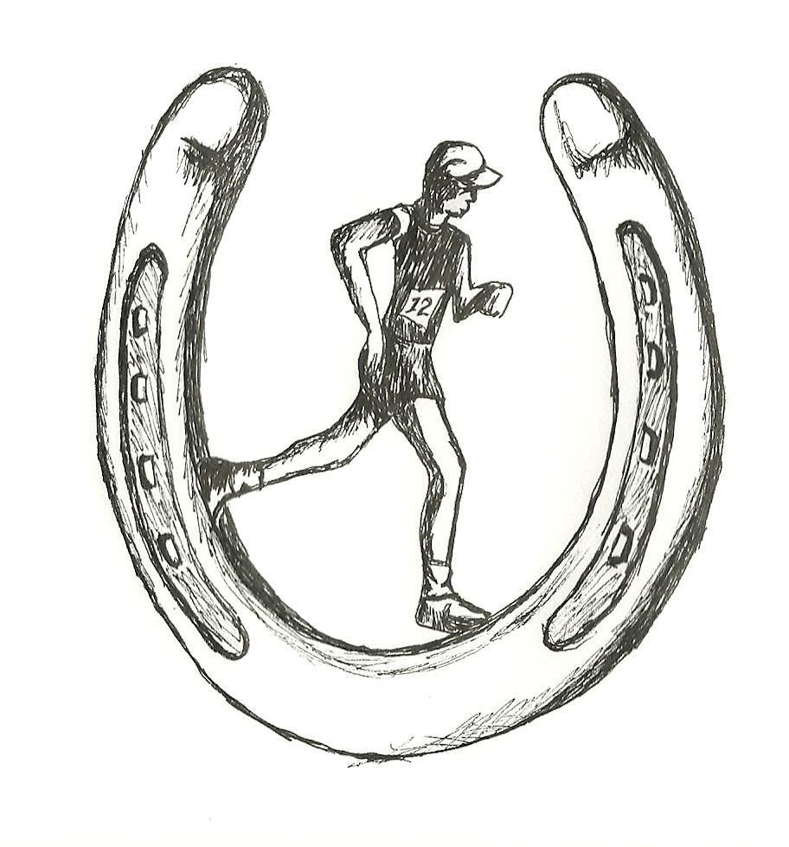

*COME HELP KICK OFF FARMERS DAY IN ROBBINS, NC*

***PROCEEDS GO TO SUPPORT THE ROBBINS FIRE RESCUE ASSOCIATION***

***THURSDAY JULY 31, 2025***

*REGISTRATION: 5:30PM RACE START 7:00PM*

*RUNNERS WILL START AND FINISH AT* **STELLAR SCOOPS ICE CREAM** *AT 305 BRANSON CIRCLE*

*$20.00 PER COMPETITOR --- NO T-SHIRT*

*$30.00 PER COMPETITOR INCLUDES T-SHIRT*

***\*\*\*\* ½ MILE KIDS FUN RUN FOR 12 AND UNDER***

***STARTS 20 MINUTES PRIOR TO 5K\*\*\*\****

***\*\*\*MUST PRE-REGISTER BY JULY 18th TO GUARANTEE T-SHIRT\*\*\****

*FOR MORE INFO: WILLIAM MCDUFFIE* [*WLRMCDUFFIE@GMAIL.COM*](mailto:WLRMCDUFFIE@GMAIL.COM)

*-----------------------------------------------------------*

*Name___________________________________________________*

*Address________________________________________________*

*________________________________________________*

*Phone____________________Email_________________________*

*Age_______ M/F T-SHIRT SIZE S, M, L, XL 2XL*

*MAKE CHECKS PAYABLE TO:* ***ROBBINS FIRE RESCUE ASSOCIATION***

*AND MAIL TO:* *WILLIAM MCDUFFIE*

*410 COCKMAN RD.*

*ROBBINS, NC 27325*